4th Meeting

28/7/2015
First : we made Temp Sensor
Using :
1- LM35
2-Resistance 1k
3- led
4-arduino
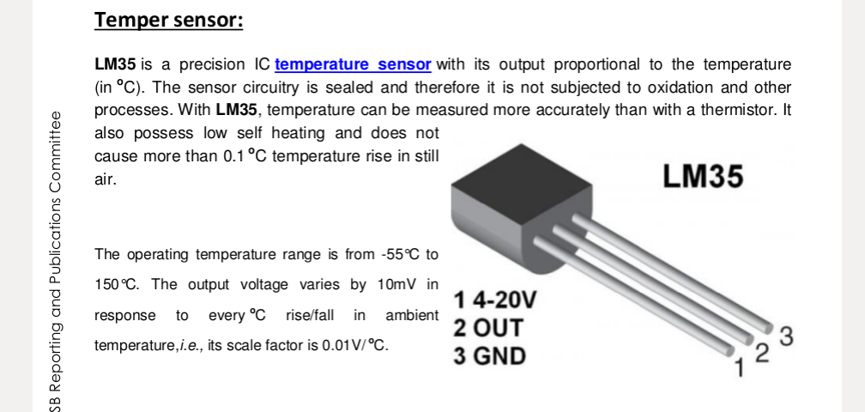
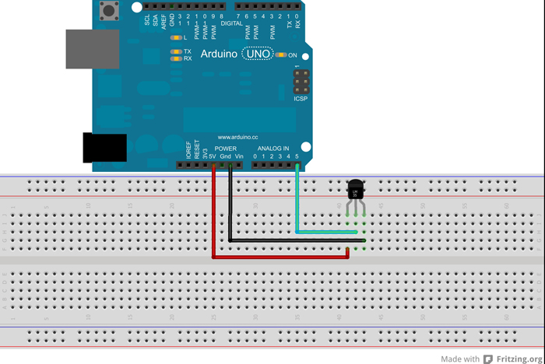

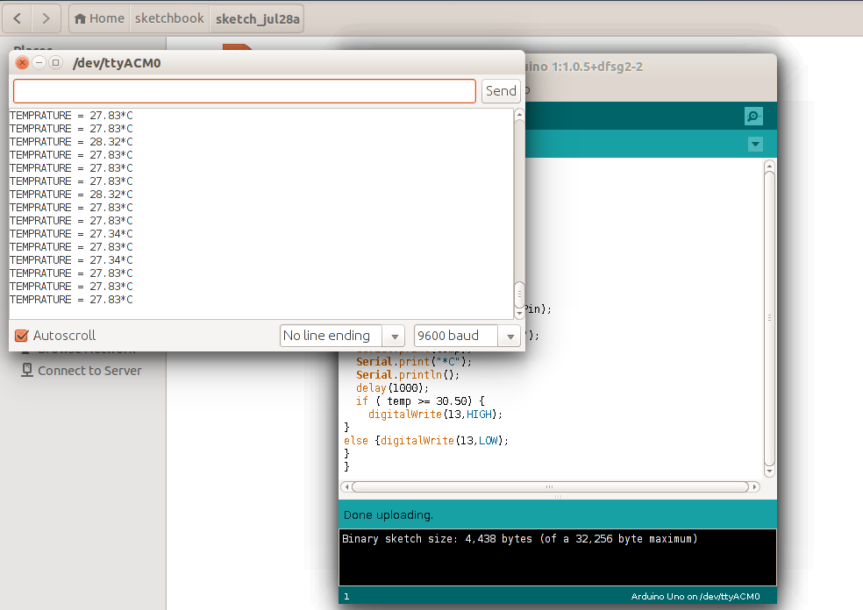

Testing with led
( alternated to Fan )

second : making bluetooth APP
using
1-appinventor.mit.edu
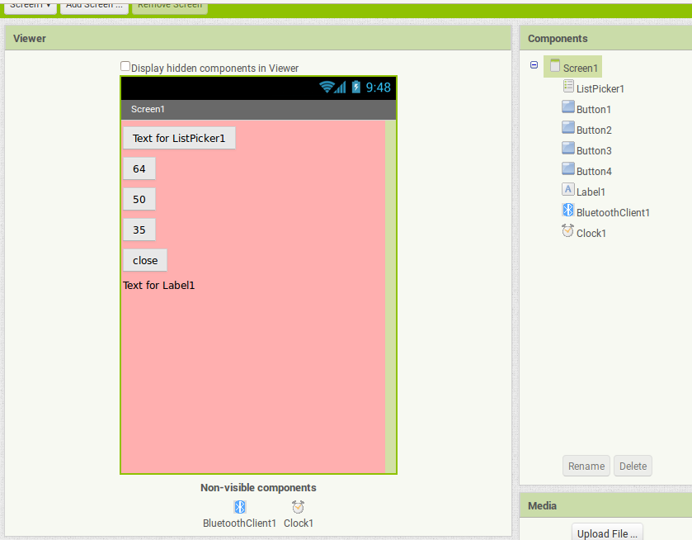
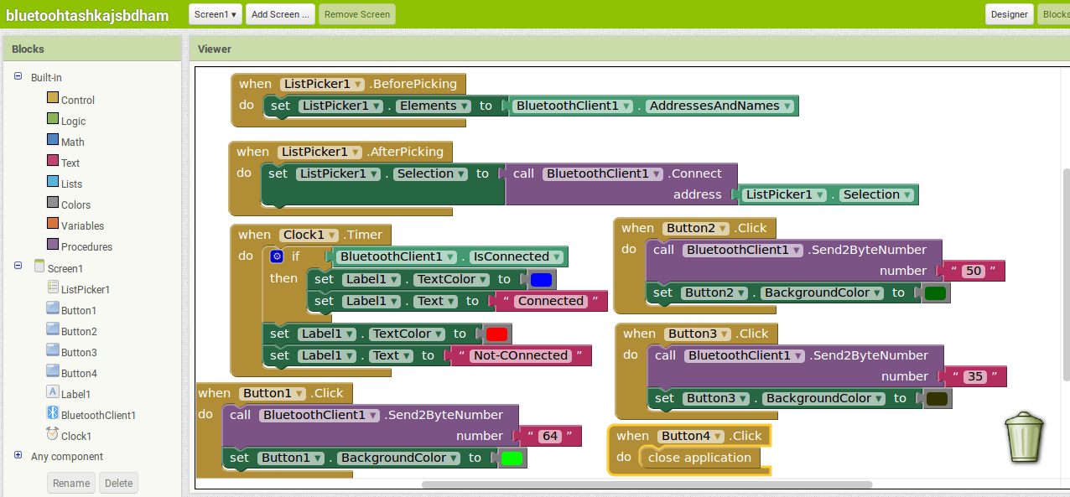
-the numbers are the bytes with is send by the button
- as arduino bluetooth module Receives char
- char = 2 bytes

Home Task :
1st ldr + connected to arduino + controlling lamp
2nd how to control lamp manual
3rd coding
@ Electra
-testing on Bluetooth module on mobile app
- working on ldr
- Testing

